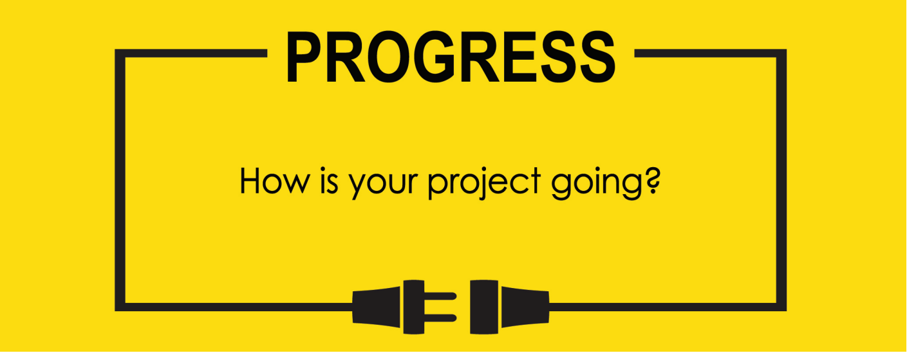

**Name: Zach Wilcox**

**Project Title: GreenBox**

**Previous Goals**

What were your three goals from last week? Were you able to complete them? If so, select Completed. If not, select the level of completion and explain in the Notes section why the goal was not completed, what still remains to be done, and when you expect to finish work on the goal.

Goal #1 from last week: Build Physical Box

**Status:** _____Completed __x___Partially Completed _____No Progress

**Notes:**

2 Week goal. Larger materials have been purchased and Idea/metal factory permits acquired. Next, shaping the metal and acrylic portions, then assembling the box. There are several smaller parts needed such as screws, rubber trimming, and hinges that have not yet been purchased.

Goal #2 from last week: Finish Circuit testing

**Status:** __x___Completed _____Partially Completed _____No Progress

**Notes:**

The control portions of the circuit were fully tested via Arduino and found to be functional. The Power portion of the circuits were also tested and aside from the cooler, which has not yet arrived, were also found to be functional. The cooler is not anticipated to be an issue in the circuit testing phase, as it is simple and will fit into the previously tested portions easily.

Goal #3 from last week: Start LCD code on MCU

**Status:** _____Completed ___x__Partially Completed _____No Progress

**Notes:**

Marked ‘Partially Completed’, as the code is not yet finished, though significant progress has been made. The initialization portions of the MCU were slightly more involved than anticipated and took much of the programming time. However, much of the initialization for other portions of the project such as the clock has also been completed, so slight progress was made in areas that weren’t initially anticipated.

**Next Three Goals**

Choose three subtasks from your Gantt chart and use them to form goals that you plan to complete this week. In the text box beneath each goal, give details about what you plan to accomplish. Include details such as what materials are needed, how many hours each day you plan to devote to the task, and so on.

NOTE: THESE ARE INDIVIDUAL GOALS THAT YOU PLAN TO ACCOMPLISH. THESE ARE NOT TEAM GOALS.

**Goal #1: Finish box build.**

**Goal #2: Finish initialization code for MCU**

**Goal #3: Begin GPIO control code.**

**The new Gantt chart is the same as the old Gantt chart, except the box assembly has been included in the timeline.**

